Lamborghini

Objective of website
The main objective of my website is to promote the Lamborghini brand and show that it is a luxurious automative brand by showcasing its high-performance cars and delivering an immersive digital experience that displays the innovation, craftsmanship and exclusivity.
Goals
- The website aims to increase business visibility
- Finding people who are likely to buy
- Providing detailed information on the vehicles
- Increasing customer loyalty for existing customers
Target audience
The target audience includes high income earners that are usually around the age of 30-60 such as entrepreneurs and celebrities etc, who have strong interest in luxury sports cars, as well as young automative enthusiast. The audience is mostly global but targeting more the likes of Europe American China and the likes as they are more into luxury and tech whilst also being more advanced.

Technical aptitude
Users will need to have basic understanding of how to navigate website to be able to get the full experience to explore the website fully and to see all the features offered by it.

Website type
The type of website that I will be creating will be a mixture of a brand website and product showcase website. This will allow users to learn about Lamborghini the values they hold and the heritage as well and will also be able to see the different luxury products that they offer.

Information architecture
The Lamborghini website's information architecture was created to create a structure that is easy to understand, intuitive, and consistent with the brand's upscale image. The website is arranged in a top-down hierarchy, with broad primary categories at the top and more specialised subpages at the bottom. Models, Heritage, and Brand are the three main sections of the navigation.
Current Models and Limited Series are the two subcategories of the Models section that let users examine the newest production cars as well as high-performance, exclusive editions that are distinctive to Lamborghini's brand. With a focus on Lamborghini's history, development, and legacy, the Heritage section provides users with information about the brand's beginnings and significant achievements. Two supporting pages are accessible through the Brand category: News, which informs users of the most recent events, announcements, and innovations, and About, which offers official company information. This taxonomy guarantees that content is arranged logically, simplifies navigation, and facilitates a seamless browsing experience for both enthusiasts and prospective customers.

Site Map (Navigation Structure)
Home
- Models
  - Current Models
  - Limited Series
- Heritage
- Brand
  - About
  - News
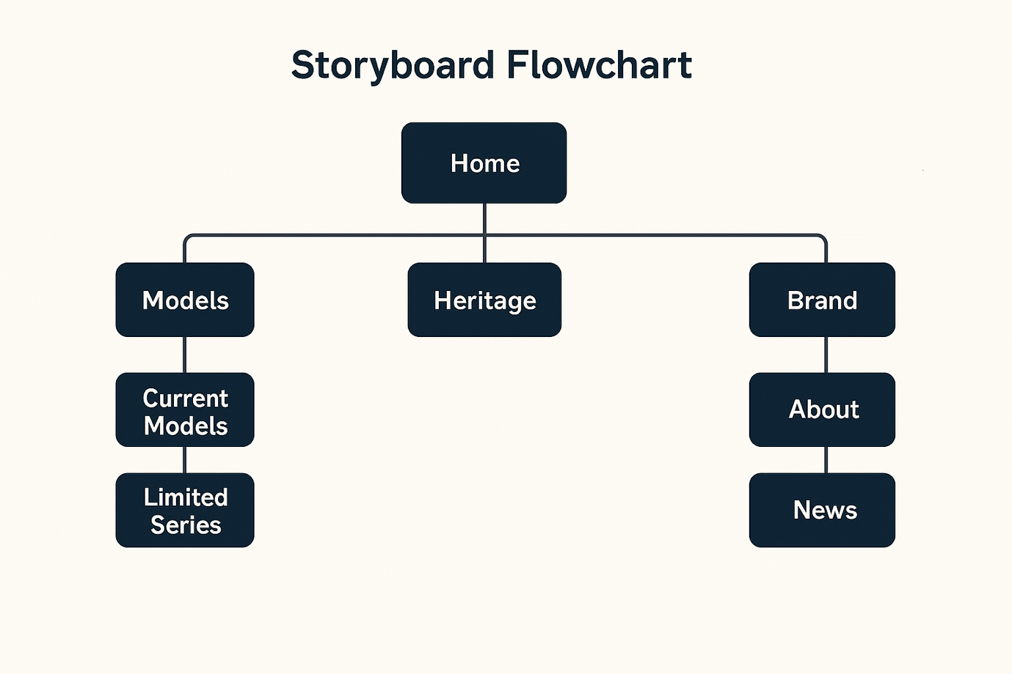
Home: the home page will feature the information and hero page for the user to view to be able to know what the page is about
Models current and heritage/limited: these two pages will feature the various models that Lamborghini offers from current models being sold worldwide to older vintage models that are not so easily accessible
Heritage: this page will feature the history of Lamborghini throughout the years showing the change in architecture technology etc.
Brand/about: this will be where users can find how to contact us and location of where to find us in order to make any queries and requests.

Technical Brief
The development of the Lamborghini website will utilize a combination of modern web technologies and supportive software tools to ensure a functional, responsive, and visually appealing design. The primary development environment will be Visual Studio Code (VS Code), a lightweight yet powerful code editor that provides extensions for HTML, CSS, and JavaScript development, making it suitable for the complexity level of this website. For guidance on coding standards, structure, and best practices, W3Schools will be used as an online reference resource to support implementation of responsive layouts, navigation systems, and modern HTML5/CSS3 techniques.
I also made use of a website called moqups to make the wireframes of the website as I found it easy to understand and design my wireframes through the website as it has easy navigation and features drop in features.
The website will be built using standard front-end technologies:
- HTML5 for structuring the site’s content
- CSS3 for styling, layout, and responsive design
- JavaScript for basic interactivity
To enhance the visual experience, lightweight assets such as high-quality images and icons will be created or optimized using Canva or similar graphic-editing tools, ensuring the site maintains Lamborghini’s premium aesthetic. Additional resources such as Google Fonts may be used to enhance typography while keeping the design consistent and modern.
These technologies and tools collectively match the website’s requirements by supporting clean design, usability, and efficient development.

